Computer Vision - Homework 2

Question 1:

* 1. - The picture loaded is shown below:

* 1. - The visualization of the Gaussian Pyramid is added as a picture below:

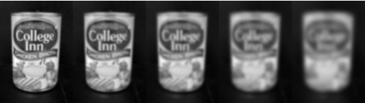

Moreover, the shape of the pyramid provided is, as printed from the code:

As can be seen, each level of the pyramid makes the picture provided be blurrier. This is because of the key feature of the gaussian pyramid, which samples the picture with a gaussian kernel with a variation that changes in each layer. The pictures above are the outputs from each variation layer.

* 1. - Creating the DoG pyramid provided us with the following sizes - 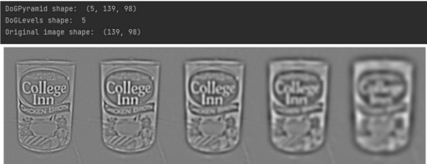

As we can see, the shape of the pyramid is the same length as we achieved, and the width is the same as the original image. Moreover, each layer provides a blurrier image, as explained in the previous section.

* 1. - For the principal curvature calculation, we calculated the differentials of the gaussian pyramid, developed the hessian matrix which represented the pyramid, calculated the eigenvalues of the matrix and used the equation given to us in the lecture to achieve the curvature ratio R for each point.
  2. - To check for extrema points we implemented a helping function called “check_neighbors” which checks for extremum compared to its spatial and scale neighbors. It determines the neighbors scale, gets special neighbors in adjacent levels and current level, and of those neighbors determines the overall extremum using the extremum conditions. The main function initializes the ‘locaDoG’ which stores the detected extrema points, iterates over levels and spatial coordinates and checks thresholds and local extrema using the “check_neighbors” function explained above.
  3. - The results on the sanity check picture are shown below:

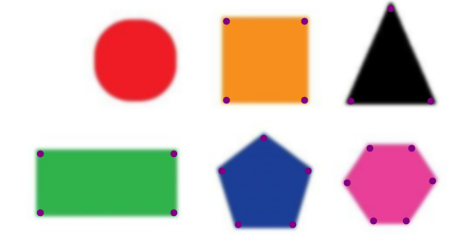

As can be seen, the edges were detected as expected.

For a real image, the results are added below:

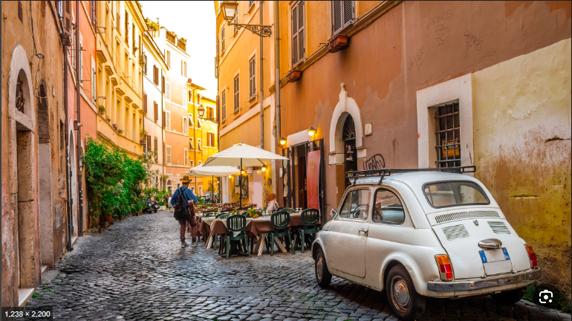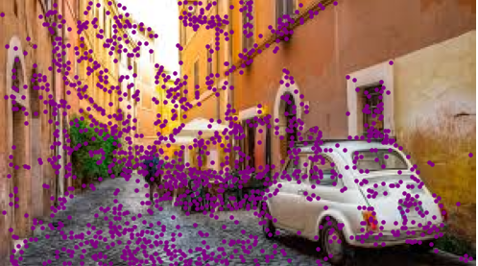

As we can see in the real world, unlike simple geometric shapes there are many situations in which the algorithm fails to detect precisely the edges. However, considering the key features in the provided picture, such as changes between the car and the background, the detection of the wheel, the door to the right and the stand in the middle of the picture - the algorithm successfully shows the corners and edges. Due to changes in brightness on the floor, combined with the shape of the floor, the algorithm detects many points of interest where each brick ends, as expected from the algorithm.